SIMATS ENGINEERING
ASSESSMENT TOOL 3

COURSE NAME: Database Management Systems
COURSE CODE: CSA0503
FACULTY : Dr.Ruby Elizebath
Student name: R Jalaja
Register no.: 192525365

1 Identify and fix the error in the given SQL query that uses incorrect JOIN syntax and returns duplicate results. 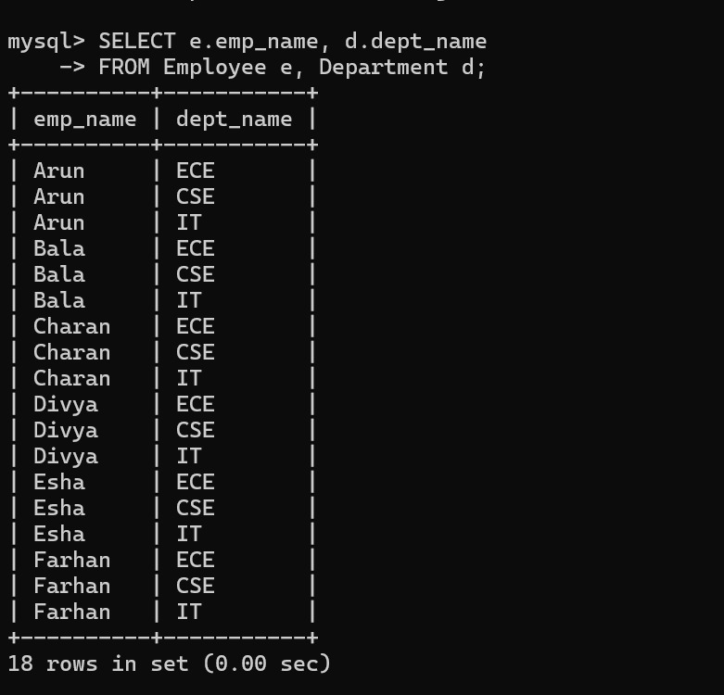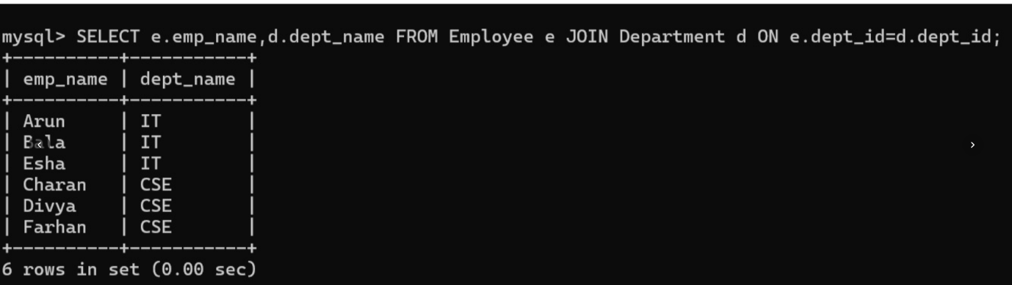

2 The following sub-query returns incorrect results due to a missing correlation. Debug and rewrite it correctly.
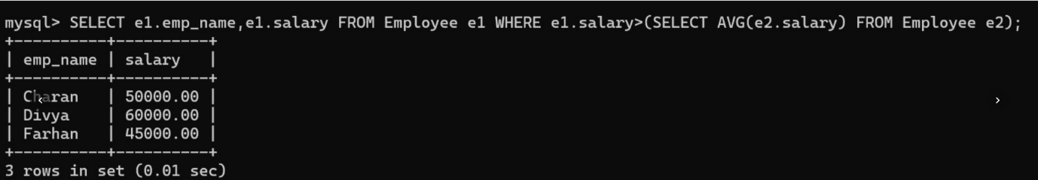
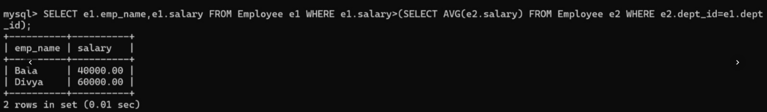

3 A given SQL view definition causes errors when queried. Identify the issue and rewrite a correct and optimized view
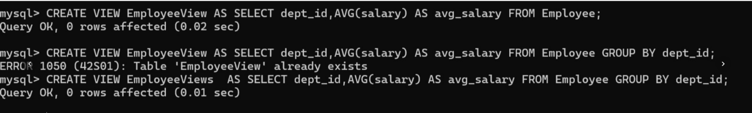

4 Debug the given relational algebra expression that produces incorrect output for a natural join operation.
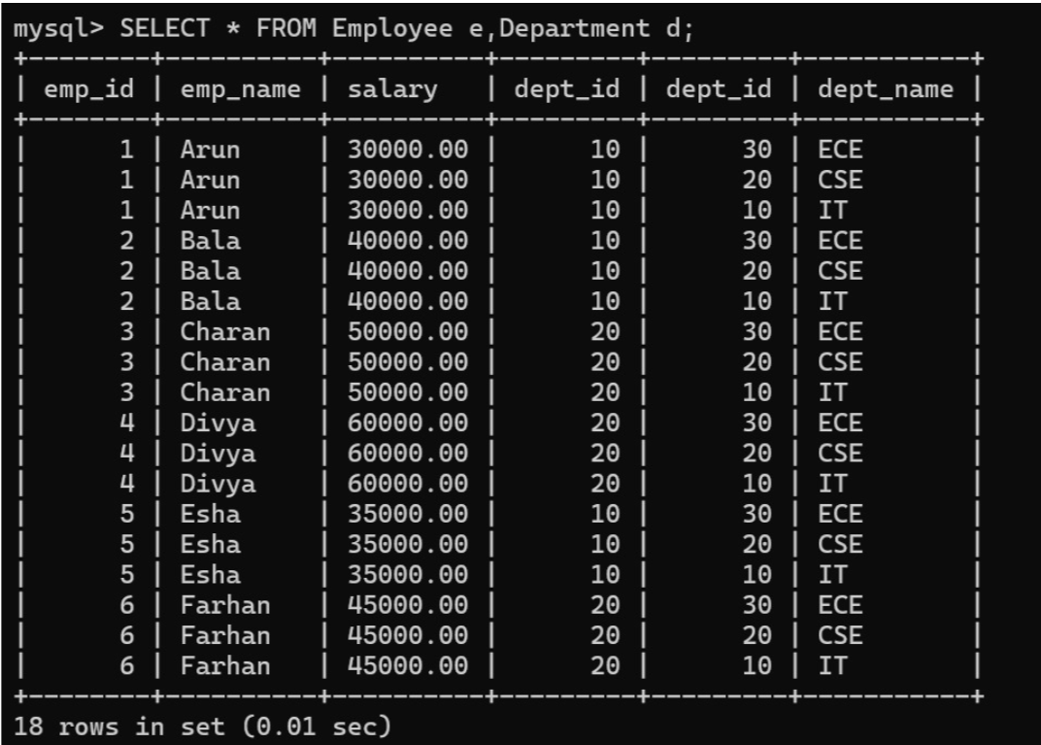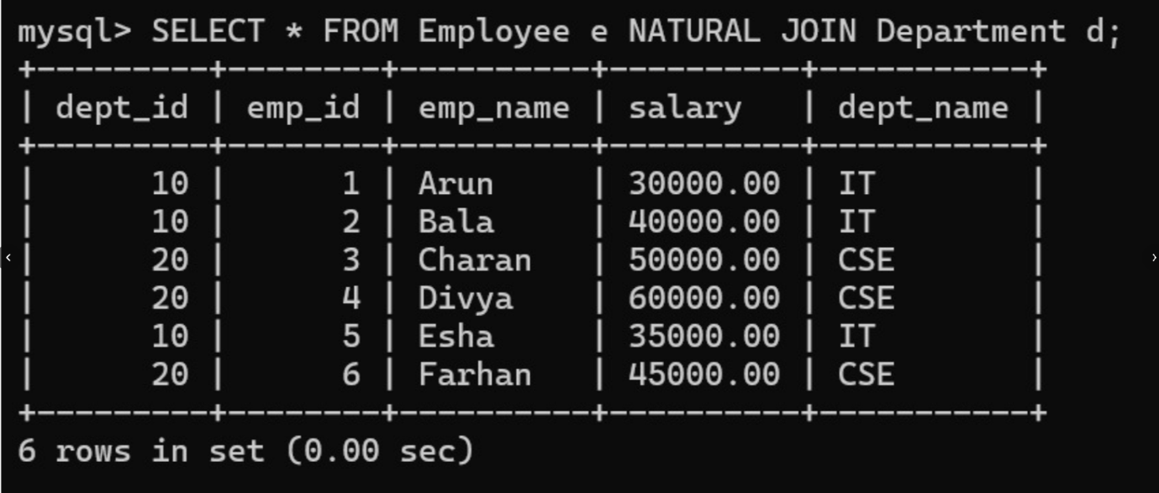

5 The SQL query below violates referential integrity. Identify the violation and modify the statements to enforce proper constraints.
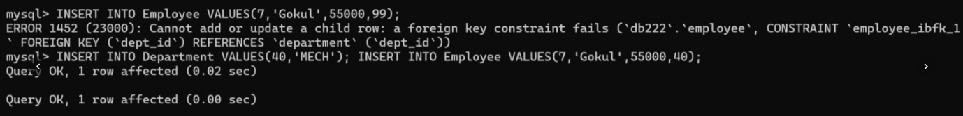
6 Given an inefficient SQL query with nested loops, rewrite it using JOIN to optimize performance.
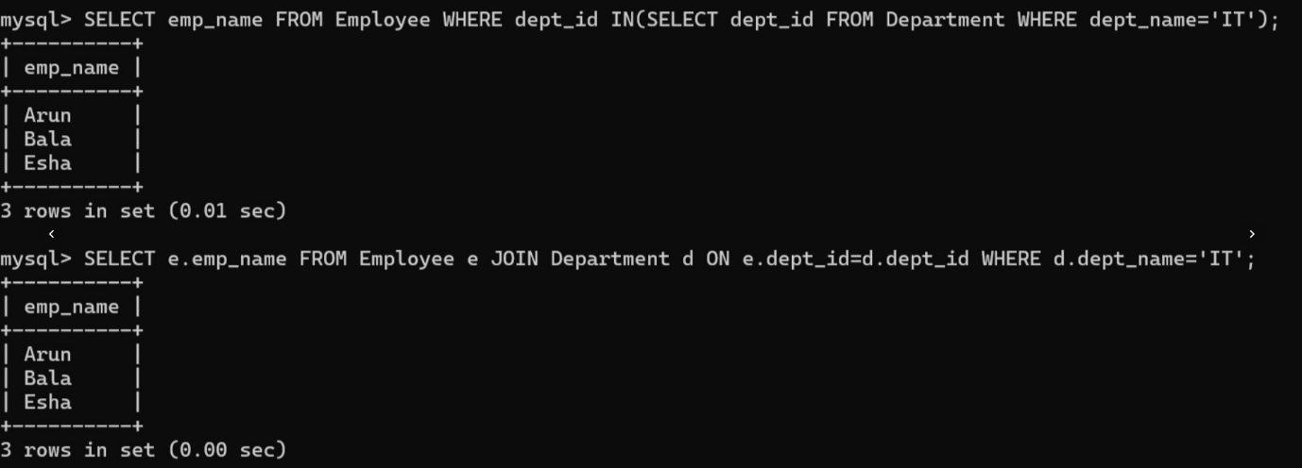

7 The GROUP BY query below produces wrong aggregation results. Debug the query and explain the error.
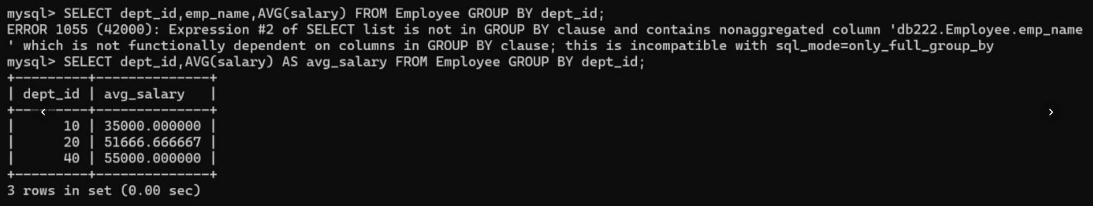

8 Identify and fix the logical error in a given SQL UPDATE statement that unintentionally modifies all rows in the table.
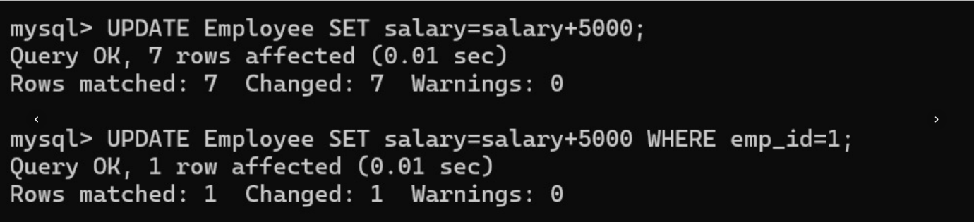

9 Optimize the given multi-table SQL query by restructuring sub-queries into JOINs and using appropriate indexes.

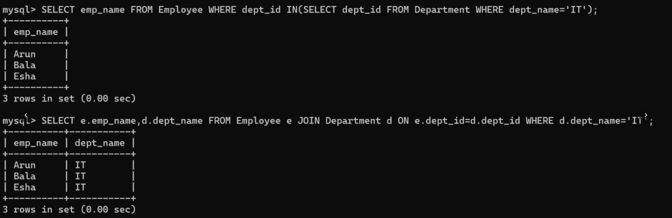

10 Debug a given relational calculus expression that returns an empty result set due to incorrect quantifier usage.

